**NAME : HARSH MITTAL**

**CLASS: CSE 4B**

**ROLL NO.-2K19CSUN0108**

MANAV RACHNA UNIVERSITY

Department of CST

(Software Engineering Lab– CSH207B-P)

(Lab 0)

**Learning Outcomes:** Students will be able to understand how to identify requirements for a project.

1. A university wishes to develop a software system for library management activities. Design the problem statement for the software company.
2. Identify the requirements of the project from the problem statement. **Ans:**
3. Any library member should be able to search books by their title, author, subject category as well by the publication date.
4. Each book will have a unique identification number and other details including a rack number which will help to physically locate the book.
5. There could be more than one copy of a book, and library members should be able to check-out and reserve any copy. We will call each copy of a book, a book item.
6. The system should be able to retrieve information like who took a particular book or what are the books checked-out by a specific library member.
7. There should be a maximum limit (5) on how many books a member can check-out.
8. There should be a maximum limit (10) on how many days a member can keep a book.
9. The system should be able to collect fines for books returned after the due date.
10. Members should be able to reserve books that are not currently available.
11. The system should be able to send notifications whenever the reserved books become available, as well as when the book is not returned within the due date.
12. Each book and member card will have a unique barcode. The system will be able to read barcodes from books and members’ library cards.

# MANAV RACHNA UNIVERSITY

Department of CST

(Software Engineering Lab– CSH207B-P)

(Lab 1)

**Learning Outcomes:** Students will be able to understand how to do design in software engineering

1. Draw the use case diagram for library management system.

Ans:

 User who registers himself as a new user initially is regarded as staff or student for the library system.

* + 1. For the user to get registered as a new user, registration forms are available that is needed to be fulfilled by the user.
    2. After registration, a library card is issued to the user by the librarian. On the library card, an ID is assigned to cardholder or user.
  + After getting the library card, a new book is requested by the user as per there requirement.
  + After, requesting, the desired book or the requested book is reserved by the user that means no other user can request for that book.
  + Now, the user can renew a book that means the user can get a new due date for the desired book if the user has renewed them.
  + If the user somehow forgets to return the book before the due date, then the user pays fine. Or if the user forgets to renew the book till the due date, then the book will be overdue and the user pays fine.
  + User can fill the feedback form available if they want to.
  + Librarian has a key role in this system. Librarian adds the records in the library database about each student or user every time issuing the book or returning the book, or paying fine.
  + Librarian also deletes the record of a particular student if the student leaves the college or passed out from the college. If the book no longer exists in the library, then the record of the particular book is also deleted.
  + Updating database is the important role of Librarian.

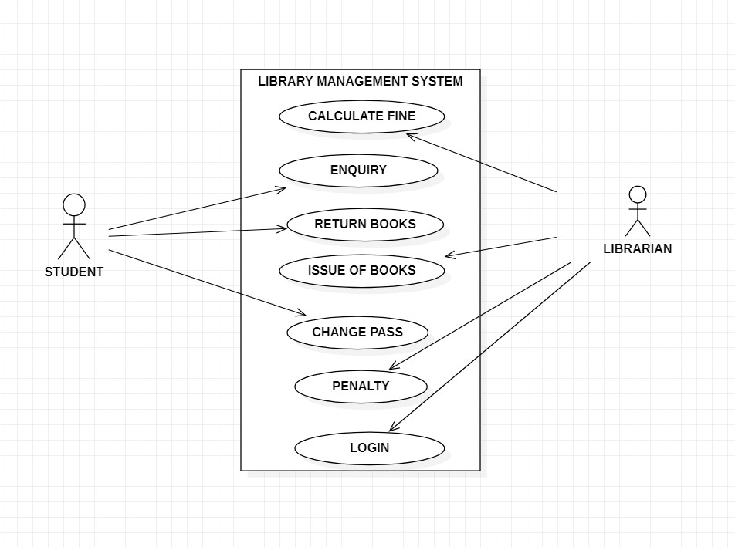

2.Draw the use case diagram for result management system.

**Ans**. The main actors of Result Management System in this Use Case Diagram are: Super Admin System User, Teacher, Student, who perform the different type of use cases such as Manage Student Manage Class, Manage Subject, Manage Exam, Manage Result, Manage Teacher, Manage Semester, Manage Users and Full Result Management System Operations. Major elements of the UML use case diagram of Result Management System are shown:

* + Super Admin Entity : Use cases of Super Admin are Manage Student, Manage Class,

Manage Subject, Manage Exam, Manage Result, Manage Teacher, Manage

Semester, Manage Users and Full Result Management System Operations

* + System User Entity : Use cases of System User are Manage Student, Manage Class,

Manage Subject, Manage Exam, Manage Result, Manage Teacher, Manage Semester

* + Teacher Entity : Use cases of Teacher are Check Exams, Publish Results, Add Marks
  + Student Entity : Use cases of Student are Search Roll No, View Results, Download Results

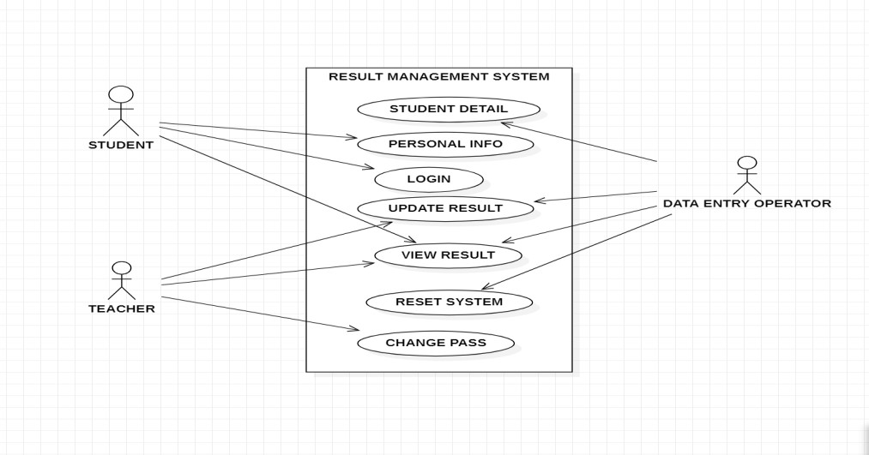

MANAV RACHNA UNIVERSITY

Department of CST

(Software Engineering Lab– CSH207B-P)

(Lab 2)

**Learning Outcomes:** Students will be able to understand how to design the database of a software system.

1. Draw the E-R diagram for library Management system.

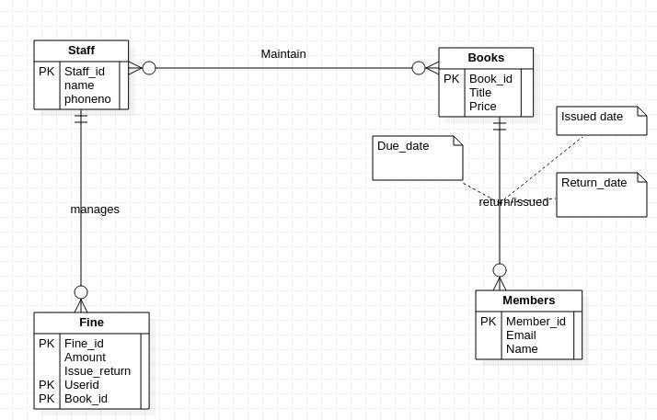

1. Draw the E-R diagram for Result Management System.

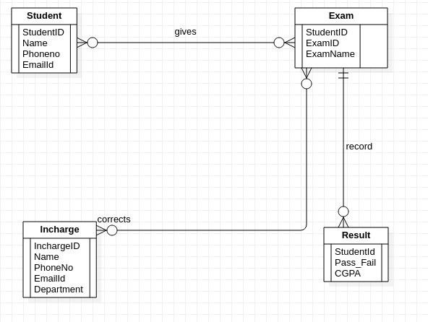



(Lab 4)

**Learning Outcomes:** Students will be able to understand how to design the architecture of a software system.

1. Draw the Data Flow Diagram for a library Management system.

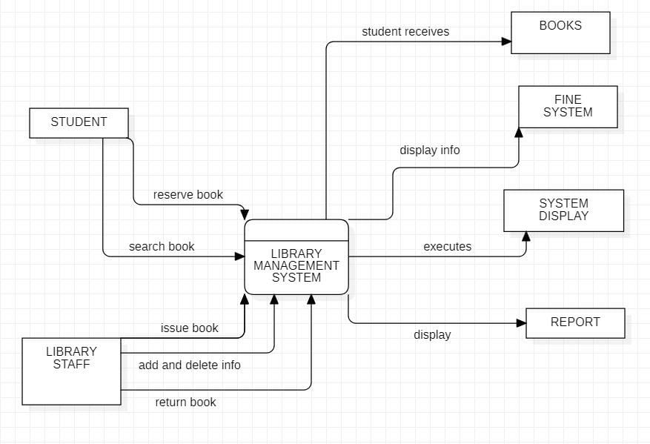

1. Draw the Data Flow Diagram for a Result Management System.

